1. Test Cases

|  |  |  |  |
| --- | --- | --- | --- |
| Setting | User input | Expected result | Actual Result |
| Enter a number of rows:  Enter a number of columns: | 1  3 | The Chronicle of the Narnia  The grapes of Wrath  Harry Potter  Total value of 3 items: $870.  Choose 1)show 2)sell 3)buy 4)quit: | The Chronicle of the Narnia  The grapes of Wrath  Harry Potter  Total value of 3 items: $870. Your bank account: $0  Choose 1)Show 2)Sell 3)Buy 4)Recite 5)Quit: |
| The Chronicle of the Narnia  The grapes of Wrath  Harry Potter  Total value of 3 items: $870.  Choose 1)show 2)sell 3)buy 4)quit: | 1 | Enter row:  Enter column: | Row:  Column: |
| Enter row:  Enter column: | 1  3 | Book: title: Harry Potter, author: J.K. Rowling, value: $223, publication year: 1997  Choose 1)show 2)sell 3)buy 4)quit: | Book: |Title: Harry Potter|, |Author: J.K. Rowling|, |Value: $223|, |Publication year: 1997| |
| Book: title: Harry Potter, author: J.K. Rowling, value: $223, publication year: 1997  Choose 1)show 2)sell 3)buy 4)quit: | 3 | Enter row:  Enter column: | Row:  Column: |
| Enter row:  Enter column: | 1  3 | The showcase is totally full. Please try again: | The location is full! Please try again!  The Chronicle of the Narnia  The grapes of Wrath  Harry Potter  Total value of 3 items: $870. Your bank account: $0  Choose 1)Show 2)Sell 3)Buy 4)Recite 5)Quit: |
| The showcase is totally filled. Please try again: | 2 | Enter row:  Enter column: | Row:  Column: |
| Enter row:  Enter column: | 1  3 | You sell Harry Potter for $223. Your bank account: $223  Choose 1)show 2)sell 3)buy 4)quit: | You sell Harry Potter for $223.  Total value of 2 items: $647. Your bank account: $223  Choose 1)Show 2)Sell 3)Buy 4)Recite 5)Quit: |
| You sell Harry Potter for $223.Your bank account: $223  Choose 1)show 2)sell 3)buy 4)quit: | 4 | The program is ended. | The program is ended. |

1. The actual time that I spent to finish the implementation was about 6 hours. Before the implementation in design document, I estimated that it will take about 3 hours, but actually it only took twice of the estimated time.
2. The output obtained from running valgrind

==15794== Memcheck, a memory error detector

==15794== Copyright (C) 2002-2017, and GNU GPL'd, by Julian Seward et al.

==15794== Using Valgrind-3.14.0 and LibVEX; rerun with -h for copyright info

==15794== Command: assign5_showcase

==15794==

Enter Rows: 4

Enter Columns: 4

Guns, Germs, and Steel The Lord of the Rings The Old Man and the Sea Capitalism, Socialism, and Democracy

Bridge to Terabithia Logisch-Philosophische Capitalism, Socialism, and Democracy The grapes of Wrath

Critik der reinen Vemunft Cosmos Critik der reinen Vemunft Logisch-Philosophische

The Lord of the Rings Harry Potter Critik der reinen Vemunft Capitalism, Socialism, and Democracy

Your total value of 16books: $6724 Your bank acount: $0

1) Show 2)Sell 3)Buy 4)Recite 5)Quit: 1

Row: 1

Column: 1

Book: |Title: Guns, Germs, and Steel|Author: Jared Diamond|Value: $480|Publication year: 1997|

Guns, Germs, and Steel The Lord of the Rings The Old Man and the Sea Capitalism, Socialism, and Democracy

Bridge to Terabithia Logisch-Philosophische Capitalism, Socialism, and Democracy The grapes of Wrath

Critik der reinen Vemunft Cosmos Critik der reinen Vemunft Logisch-Philosophische

The Lord of the Rings Harry Potter Critik der reinen Vemunft Capitalism, Socialism, and Democracy

Your total value of 16books: $6724 Your bank acount: $0

1) Show 2)Sell 3)Buy 4)Recite 5)Quit: 5

==15794==

==15794== HEAP SUMMARY:

==15794== in use at exit: 0 bytes in 0 blocks

==15794== total heap usage: 37 allocs, 37 frees, 1,781 bytes allocated

==15794==

==15794== All heap blocks were freed -- no leaks are possible

==15794==

==15794== For counts of detected and suppressed errors, rerun with: -v

==15794== ERROR SUMMARY: 0 errors from 0 contexts (suppressed: 0 from 0)

flip3 ~/assignments/assign5_showcase 1002$ vim assign5_showcase.cpp

flip3 ~/assignments/assign5_showcase 1003$ g++ assign5_showcase.cpp -o assign5_showcase

flip3 ~/assignments/assign5_showcase 1004$ valgrind assign5_showcase

==21543== Memcheck, a memory error detector

==21543== Copyright (C) 2002-2017, and GNU GPL'd, by Julian Seward et al.

==21543== Using Valgrind-3.14.0 and LibVEX; rerun with -h for copyright info

==21543== Command: assign5_showcase

==21543==

Enter Rows: 1

Enter Columns: 4

The Lord of the Rings The grapes of Wrath The Lord of the Rings Critik der reinen Vemunft

Your total value of 4books: $2166 Your bank account: $0

1) Show 2)Sell 3)Buy 4)Recite 5)Quit: 1

Row: 1

Column: 1

Book: |Title: The Lord of the Rings|Author: J.R.R. Tolken|Value: $423|Publication year: 1954|

The Lord of the Rings The grapes of Wrath The Lord of the Rings Critik der reinen Vemunft

Your total value of 4books: $2166 Your bank account: $0

1) Show 2)Sell 3)Buy 4)Recite 5)Quit: 5

==21543==

==21543== HEAP SUMMARY:

==21543== in use at exit: 0 bytes in 0 blocks

==21543== total heap usage: 34 allocs, 34 frees, 1,445 bytes allocated

==21543==

==21543== All heap blocks were freed -- no leaks are possible

==2,1543==

==21543== For counts of detected and suppressed errors, rerun with: -v

==21543== ERROR SUMMARY: 0 errors from 0 contexts (suppressed: 0 from 0)

1. Introducing a Bug
   1. <Bug Introduction>

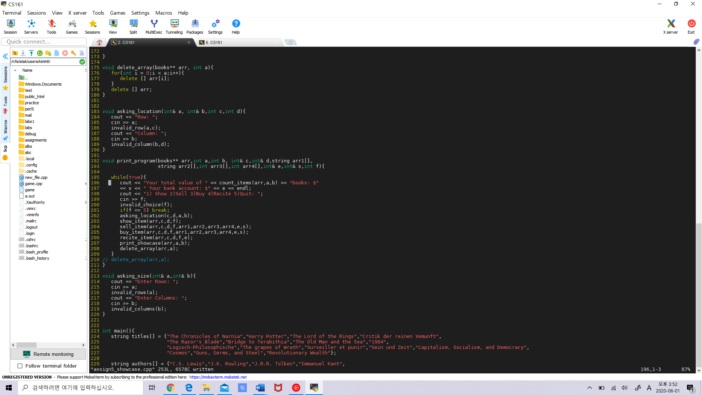



Fun1 = count_items(arr,a,b)

Fun2 = show_item(arr,c,d,f)

Fun3 = sell_item(arr,a)

Fun4 = buy_item(arr,c,d,f,arr1,arr2,arr3,arr4,e,s)

Fun5 = recite_item(arr,c,d,f,e)

Fun6 = print_showcase(arr,a,b)

Fun7 = delete_array(arr,a)

B.<The output of gdb>

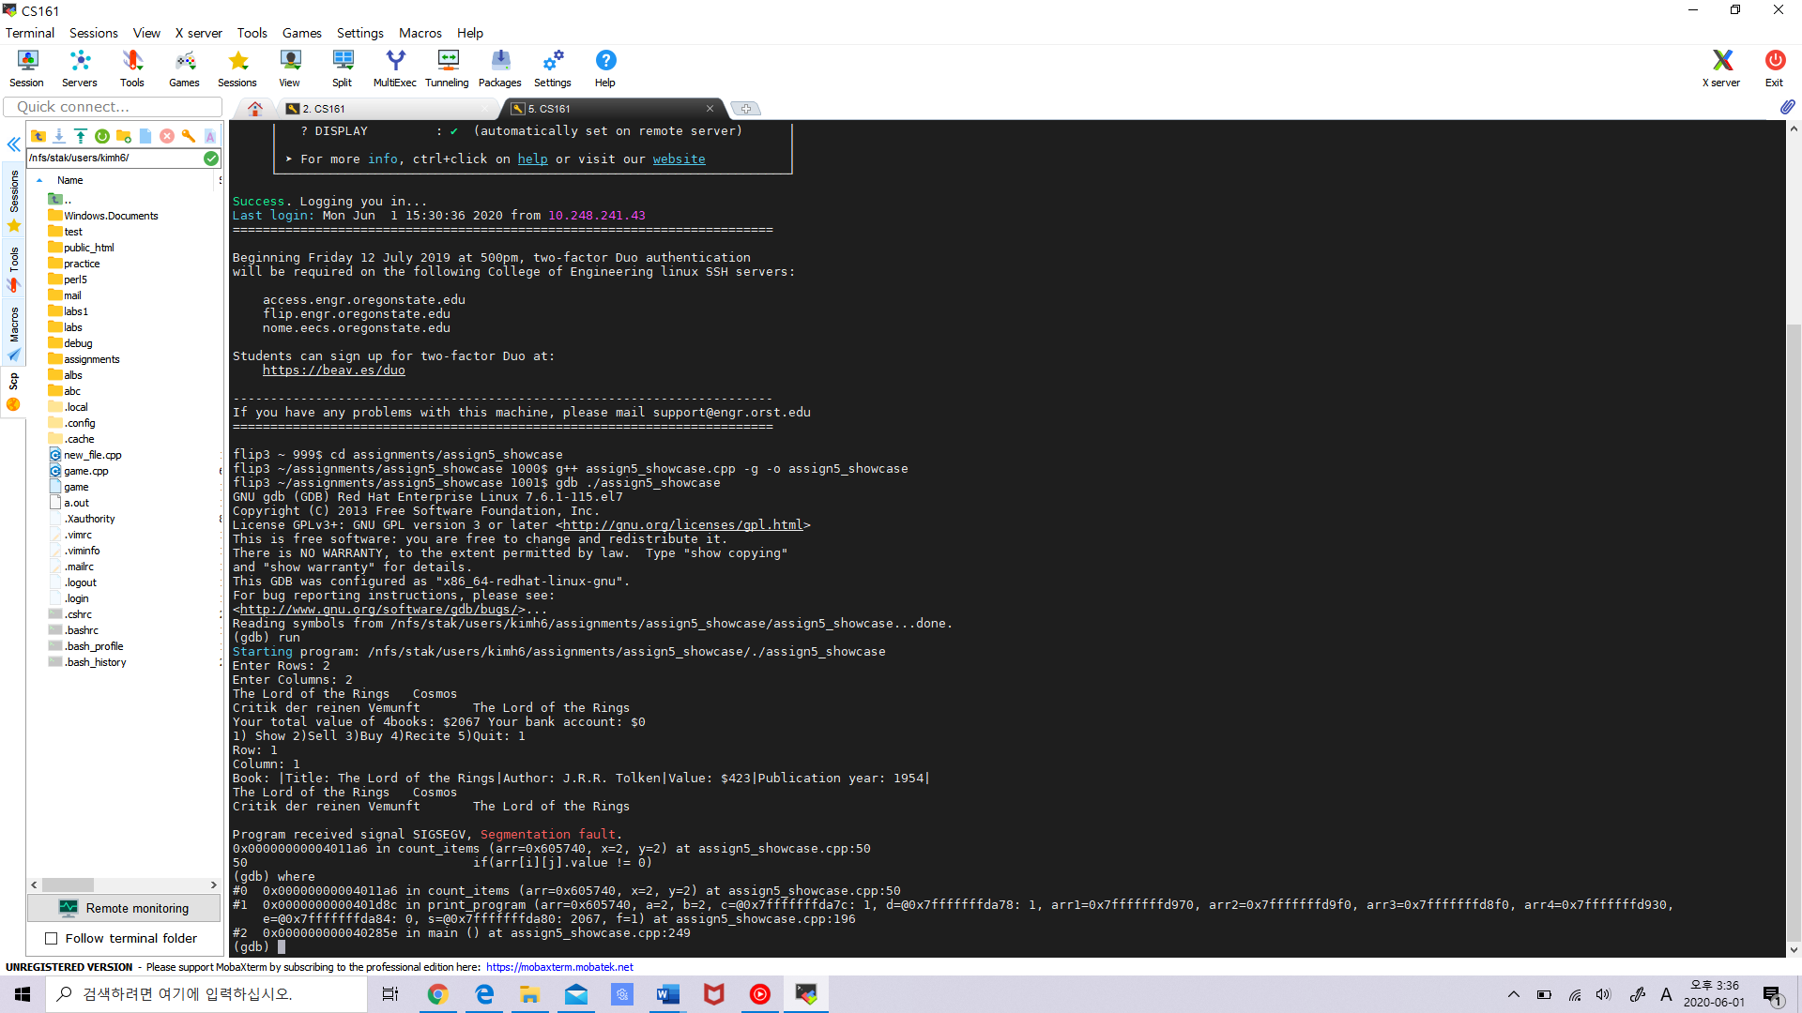

o Does gdb's output lead you to the right program line where you introduced the bug?

Yes. The output of gdb led me to the right program line where I introduced the bug.

o Write down the order of function calls that led to the place where the program crashed. (e.g., func2 -> func2 -> func3 …)

Allocated

Array (Showcase is created)

Fun2

Fun1

Fun3

Fun4

Fun5

Array is freed.

A

Fun7

Fun6

Result: Program Crashed!

<EXTRA CREDIT>

1. I asked my friend to use my program.

flip1 ~/assignments/assign5_showcase 1002$ ./assign5_showcase

Enter Rows: 4

Enter Columns: 2

Guns, Germs, and Steel Cosmos

Critik der reinen Vemunft 1984

The Lord of the Rings The grapes of Wrath

Revolutionary Wealth Bridge to Terabithia

Your total value of 8books: $3636 Your bank account: $0

1) Show 2)Sell 3)Buy 4)Recite 5)Quit: 1

Row: 2

Column: 1

Book: |Title: Critik der reinen Vemunft|Author: Immanuel Kant|Value: $856|Publication year: 1781|

Guns, Germs, and Steel Cosmos

Critik der reinen Vemunft 1984

The Lord of the Rings The grapes of Wrath

Revolutionary Wealth Bridge to Terabithia

Your total value of 8books: $3636 Your bank account: $0

1) Show 2)Sell 3)Buy 4)Recite 5)Quit: 4

Row: 1

Column: 1

You recited |Guns, Germs, and Steel| for $300.

Guns, Germs, and Steel Cosmos

Critik der reinen Vemunft 1984

The Lord of the Rings The grapes of Wrath

Revolutionary Wealth Bridge to Terabithia

Your total value of 8books: $3636 Your bank account: $300

1. Show 2)Sell 3)Buy 4)Recite 5)Quit: 5

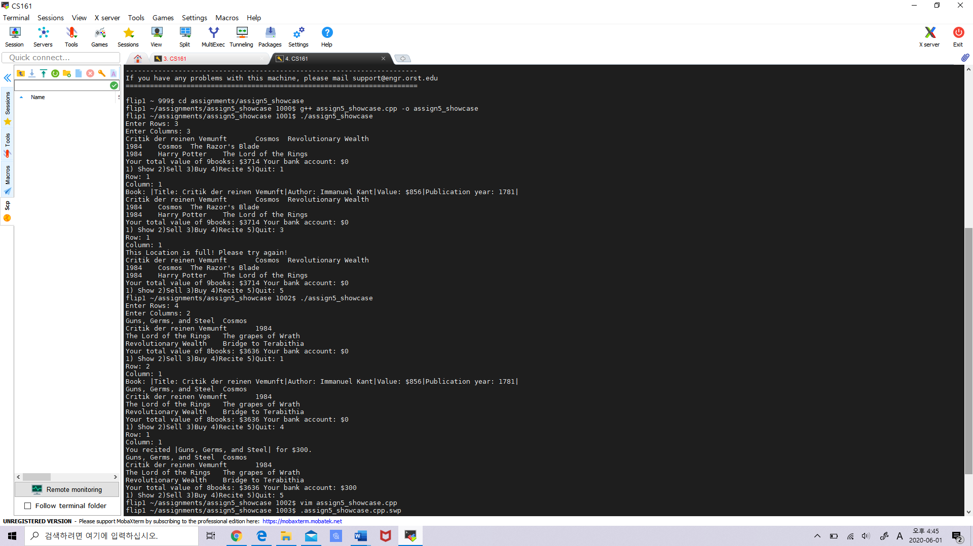

The program didn’t crash or behave in a way I didn’t expect. However, one surprising thing happened. Before my friend is going to start the program, he asked me whether my program is a game or not. I replied to him that my program is not a game, and it infinitely receives his input and prints out the changes which is depended on his input until he press the quit botton ‘5’.

1. One improvement that I would recommend to make my program more entertaining and readable is to use color codes. The reason is that the program asks the user to enter the row and the column when the user is going to determine the size of the showcase or the user is going to choose the options except quiting the program. These two cases have to be distinguished. Therefore, using color codes in order to distinguish them will make my program much more readable and entertaining.